HỌ TÊN : NGUYỄN XUÂN TRỰC
MSSV : 1513804
========================o0o========================

Windows Command Prompt: “ping –n 10 www.yahoo.com”
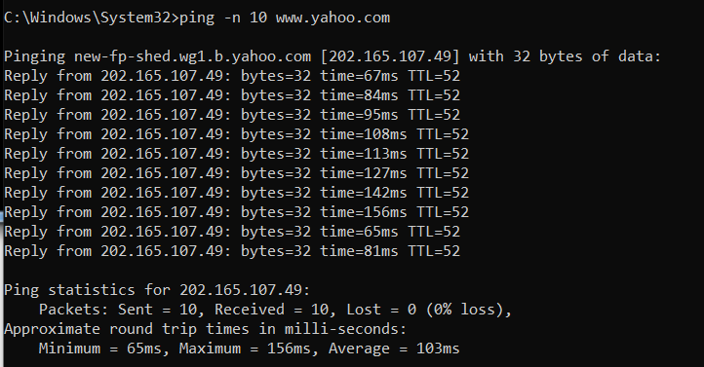
1) What is the IP address of your host? What is the IP address of the destination host?
ANSWER
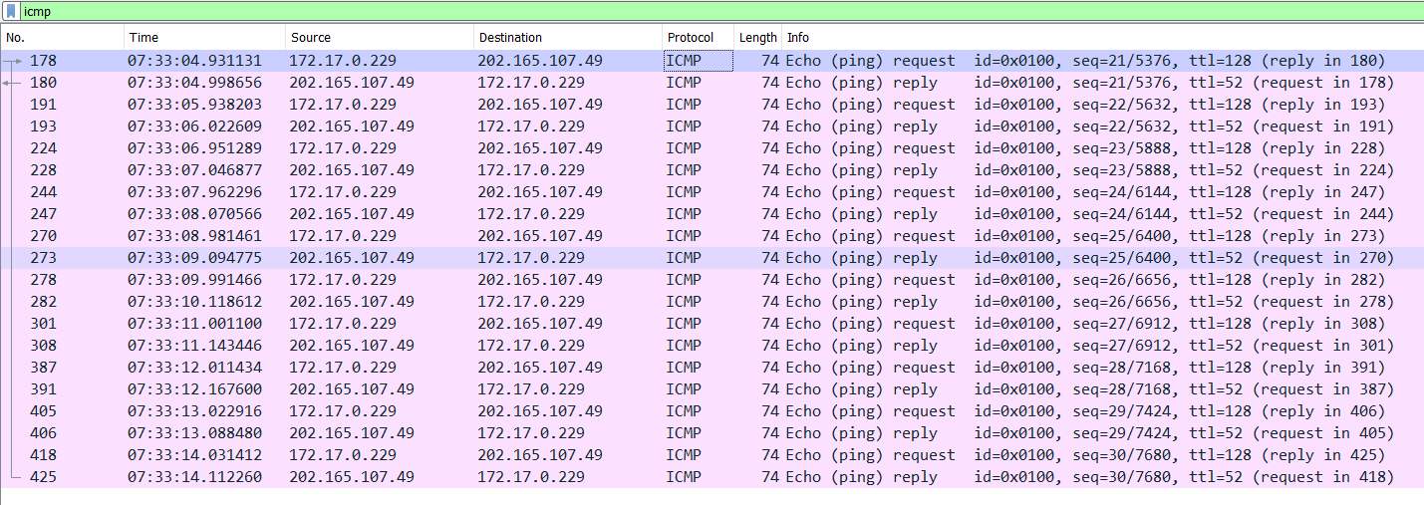
Host: 172.17.0.229
Destination: 202.165.107.49 (www.yahoo.com)

2) Why is it that an ICMP packet does not have source and destination port numbers?
ANSWER
The ICMP packet does not have source and destination port numbers because it was designed to communicate network-layer information between hosts and routers, not between application layer processes.

3) Examine one of the ping request packets sent by your host. What are the ICMP type and code numbers? What other fields does this ICMP packet have? How many bytes are the checksum, sequence number and identifier fields?
ANSWER
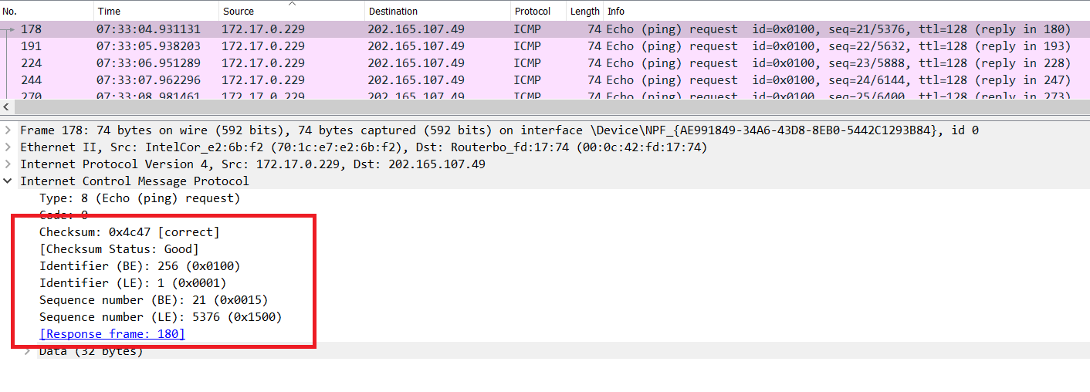
- ICMP type – 8, ICMP code 0.
- Checksum, identifier, sequence number and data fields.
- Checksum: 0x4c47
- Identifier (BE): 256
- Identifier (LE): 1
- Sequence number (BE): 21
- Sequence number (LE): 5376
4) Examine the corresponding ping reply packet. What are the ICMP type and code numbers? What other fields does this ICMP packet have? How many bytes are the checksum, sequence number and identifier fields?
ANSWER
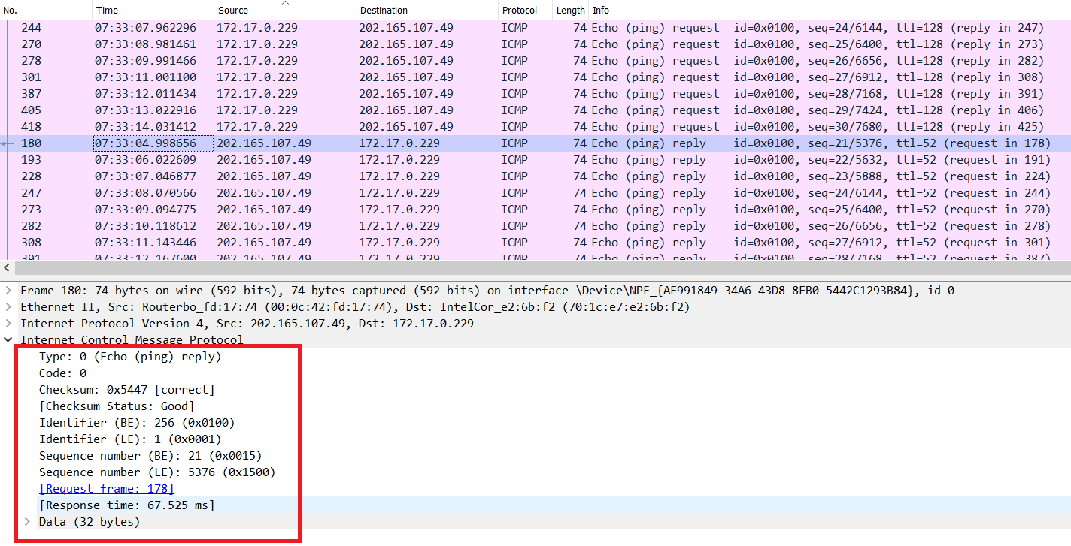
- ICMP type – 0, ICMP code – 0.
- Checksum, identifier, sequence number, and data fields.
- Checksum: 0x5447
- Identifier (BE): 256
- Identifier (LE): 1
- Sequence number (BE): 21
- Sequence number (LE): 5376

Windows Command Prompt: “tracert www.google.com”
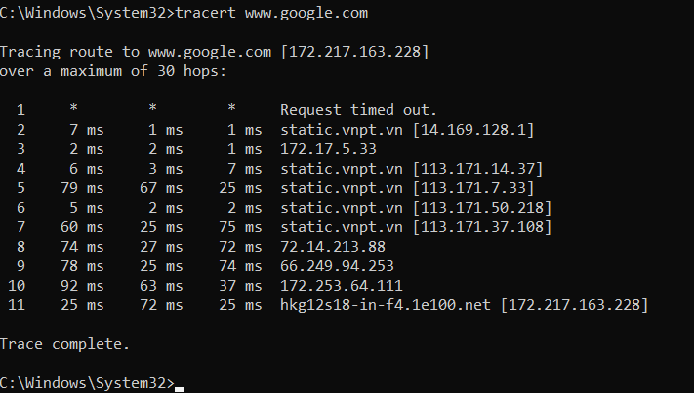
5) What is the IP address of your host? What is the IP address of the target destination host?
ANSWER
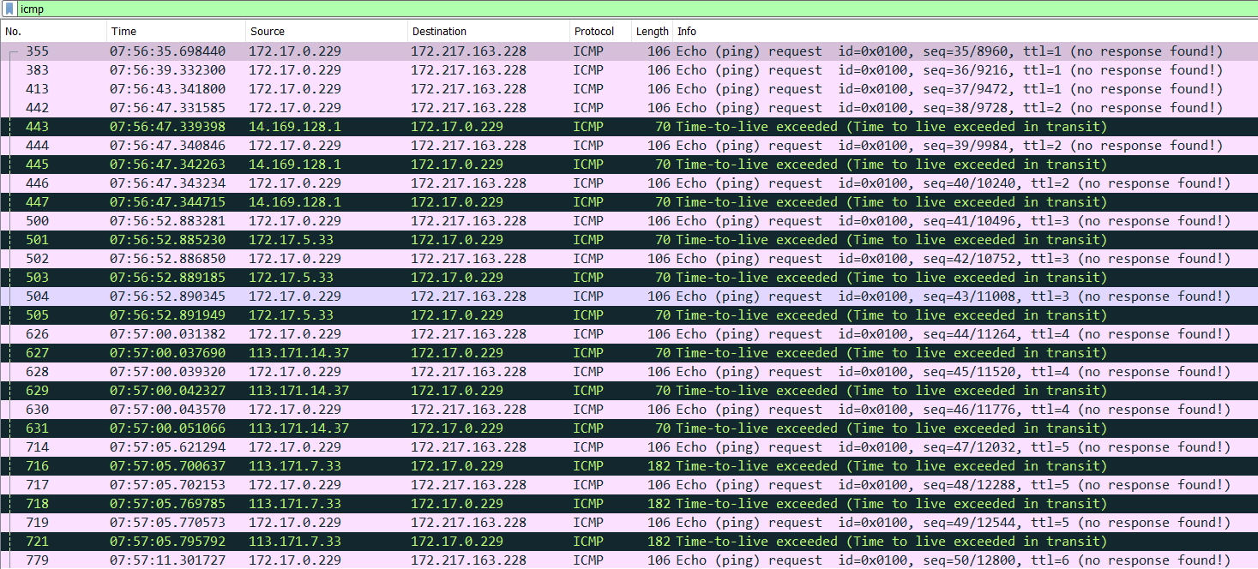
Host: 172.17.0.229
Destination: 172.217.163.228 (www.google.com)

6) If ICMP sent UDP packets instead (as in Unix/Linux), would the IP protocol number still be 01 for the probe packets? If not, what would it be?
ANSWER
No, it would be 08 instead of 01.

7) Examine the ICMP echo packet in your screenshot. Is this different from the ICMP ping query packets in the first half of this lab? If yes, how so?
ANSWER
No

8) Examine the ICMP error packet in your screenshot. It has more fields than the ICMP echo packet. What is included in those fields?
ANSWER
The IP header and the first 8 bytes of the original ICMP packet.

9) Examine the last three ICMP packets received by the source host. How are these packets different from the ICMP error packets? Why are they different?
ANSWER
- The last 3 packets are type 0.
- They are different because all the datagrams made it to the hose before the TTL expired.

10) Within the tracert measurements, is there a link whose delay is significantly longer than others? Refer to the screenshot in Figure 4, is there a link whose delay is significantly longer than others? On the basis of the router names, can you guess the location of the two routers on the end of this link?
ANSWER
- Yes, from 6 to 7 there was a long delay.
- Yes, from 9 to 10 in figure 4.
- In figure 4 the first location is NYC and the second is Pastourelle.

